[LINK TO THE GAMEPLAY](https://floridauniversitaria-my.sharepoint.com/:v:/g/personal/parofe01_alumnatflorida_es/ERVhpyfiyS9CnLl7BR7RL5cBp0gnb1_AIGPOWV2Rgu1ekQ?nav=eyJyZWZlcnJhbEluZm8iOnsicmVmZXJyYWxBcHAiOiJPbmVEcml2ZUZvckJ1c2luZXNzIiwicmVmZXJyYWxBcHBQbGF0Zm9ybSI6IldlYiIsInJlZmVycmFsTW9kZSI6InZpZXciLCJyZWZlcnJhbFZpZXciOiJNeUZpbGVzTGlua0NvcHkifX0&e=KoYirU)

ID: 4688843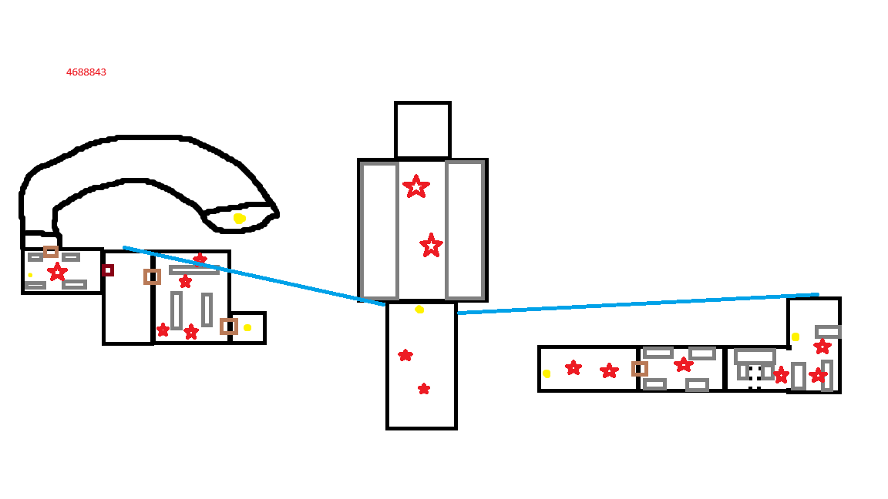

The Idea is that is a Castle where is used to fight, that’s why the amount of weapons and, of course, the doble boss in the arena, round by other monsters seeing the fight